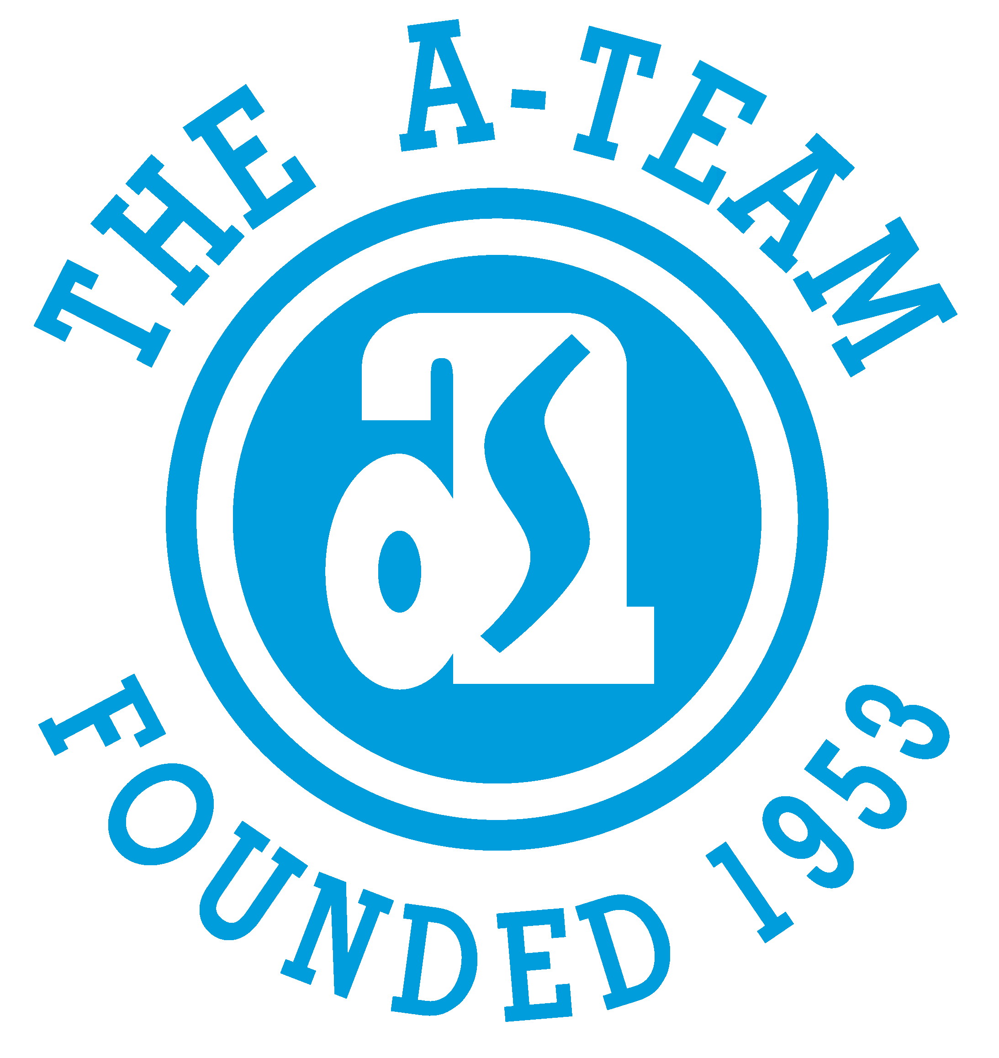

CURRENT INTERNAL JOB POSTINGS

CLICK ON link TO SEE FULL POSTING

UPDATED 4/21/25

- CUSTOMER SUPPORT SPECIALIST
Must apply by Friday, April 25th
Distyll Graphic Solutions – Adrian, MI
https://bit.ly/3EEy8ia

- COMPANY OWNED RETAIL MARKETING PLANNER
Must apply by Friday, April 25th
Adrian Steel Company – Adrian, MI
https://bit.ly/4jIOJk3

- SHOP TECHNICIAN
Must apply by Monday, April 28th
Commercial Van Interiors – Toledo, OH
https://bit.ly/42UfXyn

- OUTSIDE SALES REPRESENTATIVE
Must apply by Monday, April 28th
Commercial Van Interiors – Toledo, OH
https://bit.ly/3EGNXVD

- OUTSIDE SALES REPRESENTATIVE
Must apply by Thursday, May 1st
Advanced Work Vans – Lakeland, FL
https://bit.ly/4jOqz7H

